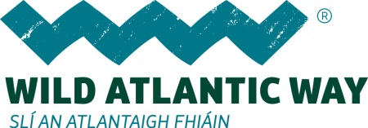

ADVENTURE ON THE BAY COAST AND NORTHERN HEADLANDS

SAMPLE 6 DAY ITINERARY

DAY 1

Morning

Option 1 - Hiking in Connemara National Park

Your starting point is the visitor centre at the Connemara National Park. From here, the fully signposted and surfaced track takes you along the Sruffaunboy Nature Trail before branching off towards the cone of Diamond Hill. Gravel footpaths and wooden boardwalks ease your passage over the bog as you approach the mountains, with a steady climb up the western slopes to the summit ridge. The ridge is a narrow fin of quartzite roughly half a kilometre long, which culminates in a cairn that marks the 445m-high summit. From here, look to the sea to Inishturk, Inishbofin and Inishshark; to Tully Mountain rising over Ballynakill Harbour and along the intricate Connemara coastline. To the north and east, the Twelve Bens are nothing short of sensational. To the northeast, Kylemore Abbey’s gothic turrets stand out from neighbouring Kylemore Lough; and directly north, the summit of Mweelrea, Connaught’s highest mountain, can be seen peeping out.

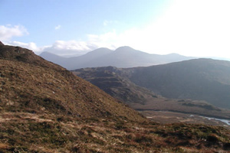

Your return to the visitor centre is along the same path as you made your ascent.

Option 2 – Sea Kayaking in Killary Fjord

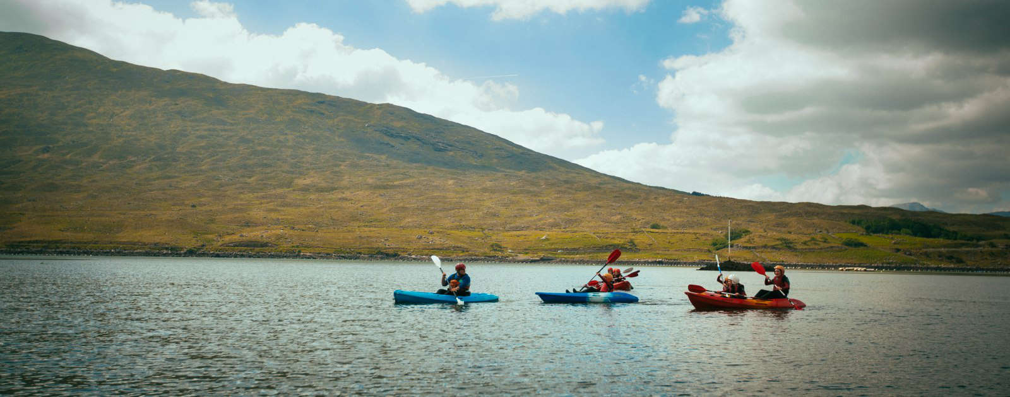

Sea Kayaking along Ireland’s most spectacular fjord, an exciting and adventurous journey of discovery of nature. Get to meet seals and dolphins along the way. www.connemarawildescapes.ie
email: info@connemarawildescapes.ie
Tel. +353 9549052

Afternoon
Connemara Cycle Tour
The journey of discovery begins at Delphi Valley and then on to the spectacular Ashleigh Falls. Your guide will then take you into Leenane Village where you will witness Ireland’s spectacular fjord and landscape around Killary Harbour.

www.allthingsconnemara.ie

Overnight Renvyle - for a range of accommodation options click here

Day 2
Morning

Option 1 - Sail on a catamaran
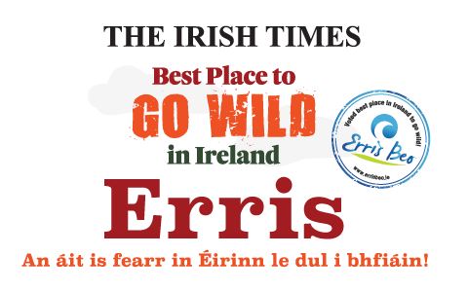
Learn how to sail on a catamaran or try your hand at kayaking and windsurfing with UISCE - a unique activity centre that teaches watersports through the Irish language. From turf to surf – learn how to ride the waves with the centre, which has been attracting students from all over the country for over 21 years, and provides day sessions for adults and families.
Elly Bay, Co Mayo
Tel: +353 (0) 97 82111
Email: eolas@uisce.ie
Web: http://uisce.ie/

Option 2 - Discover Ballycroy National Park

Ballycroy National Park comprises 11,000 hectares of Atlantic blanket bog and mountainous terrain, covering a vast uninhabited and unspoilt wilderness dominated by the Nephin Beg mountain range. Between Nephin Beg and Slieve Carr, at 721 meters above sea level, the highest mountain in the range, lie the Scardaun Loughs.
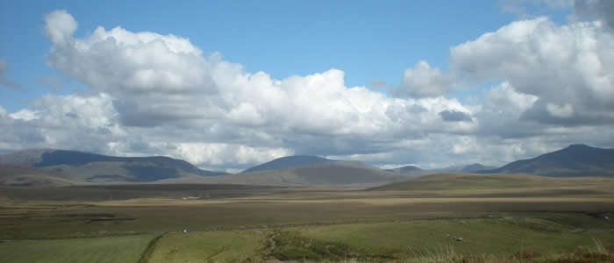

www.ballycroynationalpark.ie

Afternoon

Discover Ireland’s emigration story
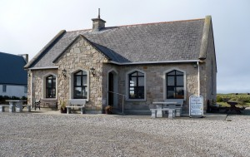
Living beside the Atlantic Ocean in Ireland wasn’t easy in the past. You’ll see exactly why when you spend time at the Ionad Deirbhile Heritage Centre at An Eachléim, in County Mayo’s Gaeltacht (Irish-speaking) area. At the Assisted Emigration Exhibition, you’ll learn some of the heartbreaking stories of the 19th century families that were forced either by famine or poverty to leave Irish shores and journey across the Atlantic for a new life. You’ll discover a trove of information about communities on the isolated Mullet Peninsula, and you’ll be taken back to the hard times when thousands of local people left by boat for Canada and the US… never to return.

Ionad Deirbhile Heritage Centre
Eachleim
Blacksod
Co Mayo
Contact: Jacqui D Uí Mhonacháin
Tel: +353 (0)97 85727
Email: eolas@ionaddeirbhile.ie
http://ionaddeirbhile.ie/

Overnight Belmullet - for a range of accommodation options please click here

Day 3

Morning

Option 1 - Ride the Tide – Kayaking on the River Moy, Paddle & Pedal
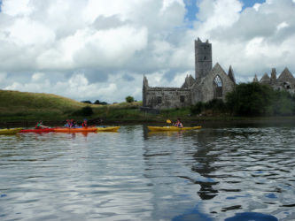
Discover the beauty of Ballina from the water. This is our most popular tour. Starting at the Quay in Ballina you will journey up river along Belleek Forest and through Nimmo's Canal where you will see amazing flora and fauna such as Kingfishers, Seals and Salmon jumping right beside you. We will continue on all the way to the famous Ridge Pool passing under the two bridges that span the river in the heart of Ballina. On the return leg we will get up close to the Crete Boom or "the stone boat" before returning to the Quay slip way. This tour is tide and weather dependent so the tour takes place at different times each day.

Circular Road, Ballina, Co Mayo
Contact: David Horkan
Tel: +353 87 680 8955
Email: david@paddleandpedal.ie
Web: www.paddleandpedal.ie
FB: www.facebook.com/PaddlePeda...

Option 2
Walk on the edge of the Wild Atlantic Way
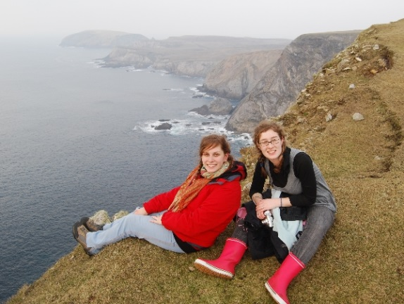
Carrowteige is one of the most secluded and isolated corners of the West of Ireland, so a visit to this area really is a true escape. On a walking tour with Trek West, you’ll get to hike along spectacular cliffs on the very western edge of Europe, taking in superb coastal views of the Wild Atlantic Way as you go. You’ll see and hear waves crashing against the ancient rocky cliffs, look out over the edge of a deep natural inlet, and marvel at the wide expanse of ancient bog land and mountain scenery. Along the way, your guide will point out native birds, seals and maybe even whales, all in their natural habitat. You’ll also hear stories and legends from the area, of St Patrick and the Children of Lir – not to mention hear spoken Irish in one of the few remaining Gaeltacht areas in the west.

Carrowteige Loop Walks | Trek West Tours
1 Emmet St. Ballina, Co Mayo
Contact: Susan Heffernon
Tel: +353 (0)96 76586
Email: info@trekwesttours.ie
Web: http://www.trekwesttours.ie/

Afternoon

Monasteries of the Moy Greenway

Phase 1 of the Monasteries of the Moy Greenway (opened 9th July, 2016) is a 4km cycle/walkway which runs through the magnificent Belleek Woods, and finishes at Knockitanole. The much anticipated route takes its name from proliferation of Catholic ruins which pepper the route to Killala (more information on which can be found on sacredlandscapes.ie.) The Greenway, the second route of its kind in County Mayo is a greenway for everyone, and is designed to accommodate walkers, cyclists, joggers, and dog owners alike, with mutual respect required for all.
When complete, the Monasteries of the Moy Greenway will be a 12.5 km cycling and walking route winding along the Moy western bank from Ballina to Killala and reaching some ancient abbeys and historical sites including Moyne Abbey and Rosserk Abbey. The project is to be developed on a phase-by-phase basis.

https://www.facebook.com/Monasteries-of-the-Moy-Greenway-1418739038408152/

Whiskey Appreciation Sessions – Rachel’s Irish Adventures

During one of Rachel’s (Sales and Marketing Manager for the new Connacht Whiskey Distillery) fun, interactive sessions, you will gather in a traditional local cosy bar for an absorbing journey through the ages. Beginning with the origin of whiskey, she will share with you from her years of industry experience tales of whiskey’s colourful past, and will explain the painstakingly fine art of distilling resulting in the smooth, golden liquid which clings so appealingly to the glass you’re holding. Rachel guarantees to change the way you think about whiskey.

Connacht Whiskey Distillery
Contact: Rachel Nolan
Phone:+353 85 1108969
Email: info@rachelsirishadventures.com
http://rachelsirishadventures.com/

Immerse yourself in 400 years of Irish History - The Jackie Clarke Collection
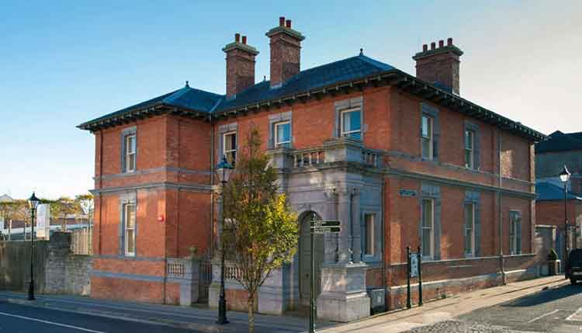
The collection is made up of many rare and important books on the history of Ireland, together with manuscripts, photographs, legal papers, pamphlets, hand-bills, newspapers and more, plus articles and proclamations (including 1916 and the rarer 1917 proclamation).

The Jackie Clarke Collection
Pearse Street, Ballina, Co Mayo
Contact: Austin Vaughan/ Anne Marie Forbes
Tel: +353 96 735 08

Overnight Ballina – for a range of accommodation options please click here

Day 4

Sligo Seashore Secrets Discovery Tour
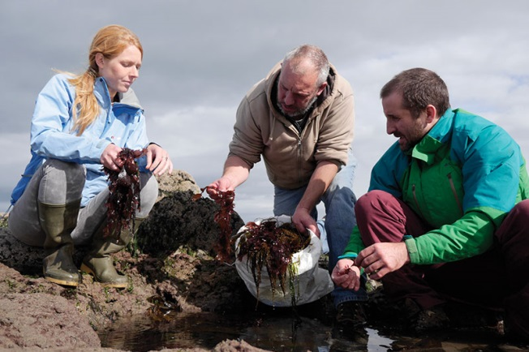
Make a walk along the seashore even more interesting with an expert guide. Marc from Seashore Veg leads these fun and informative seaweed identification walks in West Sligo. He’ll not only show you how to identify the various seaweeds but you will also learn how to use them. At the end of the walk you’ll
enjoy a practical demonstration on how to cook and use the sea vegetables. This unusual food experience also includes a delicious lunch of Aughris Seafood Chowder with dillisk bread and carrageen whiskey cream at The Fairgreen, Creative and Culinary Centre in Skreen.

Sligo Seashore Secrets Discovery Tour
Aughris
Co Sligo
Marc Torrades
Tel: 00353 87 2450862
Email: sligoseashoresecrets@gmail.com

Relax in a Kilcullen Seaweed Bath
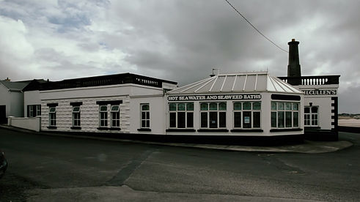
Imagine relaxing in an enormous bath filled with luxurious oils, floating in warm amber-tinted seawater and feeling simply weightless. This is the experience of a true seaweed bath, considered by many to be the ultimate bathing experience. Here, the unpolluted waters of the Atlantic are pumped in from the shore, which is just a stone’s throw away. Then the seawater combines with natural silky oils extracted from seaweed using a simple process. Together, they create an unforgettable experience that is sure to leave you feeling rejuvenated.

Kilcullen’s Seaweed Baths
Enniscrone, Co Sligo
Tel: +353 96 362 38
http://www.kilcullenseaweedbaths.net/

Afternoon

Conquer Knocknarea Mountain
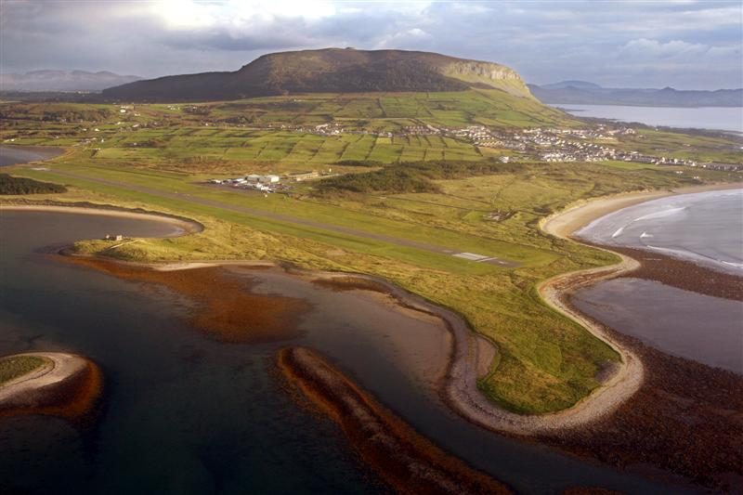
The 327 m (1072.83ft) high mountain known as Knocknarea (Irish: Cnoc na Rí) totally dominates the CuilIrra peninsula. Sitting proudly on top is Queen Maebh’s Cairn (Miosgán Meadhbha), a Neolithic passage tomb. The cairn is 55m (180.45ft) wide by 10m (32.8ft) high and has never been excavated. It is directly in line with Carrowmore and other associated ancient sites in Sligo and beyond. There is a walking trail to the top and the walk is suitable for most fitness levels. The vista from the top is well worth the effort to get there! It is said that Queen Maebh a legendary chieftain queen of Connaught is buried beneath the cairn in full battle regalia, standing upright and facing her enemies in Ulster. Tradition suggests bringing a rock from the base to leave on the Cairn to receive good luck.

Knocknarea, Sligo
Web: http://www.sligowalks.ie
Trail starts at Dolly’s cottage on the R292 near Strandhill, parking at Sligo Rugby Club.

Evening

Eat and drink the poetry of WB Yeats - Yeats Experience
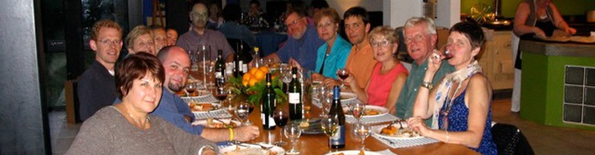
It’s no secret that Irish poet William Butler Yeats was inspired by the landscape of County Sligo. This is where he spent his childhood holidays, and set such famous poems as The Lake Isle of Innisfree.
During this experience, you’ll learn all about that poetry over an intimate lunch or dinner in Broc House, surrounded by art and architecture. Enjoy the view from the terrace, taking in several locations featured in Yeats’s work. Tuck into sandwiches, seasonal soup, salads from the garden and Irish tea brack, while you listen to Damien Brennan tell the inspiring story of a visionary writer and his beloved Land of Heart’s Desire. This is about landscape, and bringing a Nobel Prizewinner’s poetry to life. You’ll leave relaxed, inspired – and probably heading to the nearest bookshop to buy a book of poems. Oh, and you’ll eat amazingly well, too!

Feed your cultural appetite with the Yeats Dining Experience at Broc House. This is a private dinner in the private home of well-known local foodies Damien Brennan and Paula Gilvarry. The couple share a passion for fine food and entertaining as well as for the poetry, culture and heritage of Sligo, all of which they combine with a chef’s flair into a wonderful evening out. Paula sources the best of local and organic produce, while Damien feeds the soul, between courses, with some of WB Yeats’ best-loved poetry for a truly magical evening.

Tobernalt, Holy Well Lane,
Aughamore, Near Carraroe, Co Sligo
Contact: Damien Brennan
Tel +353 87 2320820
Email: yeatssligo@gmail.com
Web: www.yeatssligoireland.com

Yeats Experience is part of Sligo Food Trail
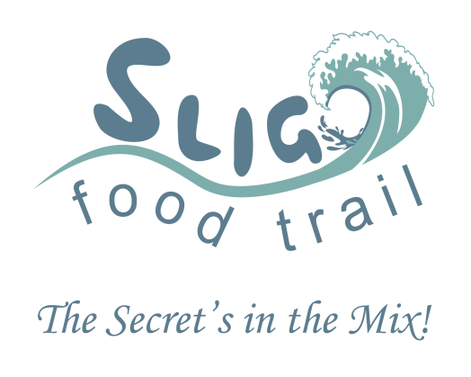
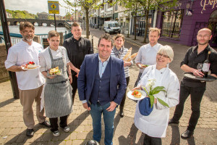
Sligo Food Trail treats your palate to an abundance of culinary treasures. You can map your own route to choose the cuisine that you love best. Welcome to foodie heaven!What makes Sligo such a fantastic foodie destination is the culture that goes hand in hand with your food experience! Producers and Food Trail members take pride in giving you fresh, local, healthy, (and very often) organic food that nourishes your body while the scenery nurtures your soul.
As you drive through Sligo, you’ll witness the outstanding landscape which yields the fresh ingredients that create its exceptional cuisine: the lush green fields, the majestic mountains, the charming farms, the salmon rivers, and the mighty Atlantic Ocean! Sligo’s premiere location on the Wild Atlantic Way means you can enjoy freshly-caught fish in any local restaurant. Alternatively, indulge your taste buds on Knocknarea honey, wild Mullaghmore lobster, Lissadell oysters, and fresh eggs from the foot of Benbulben Mountain. Whatever your food preference, Sligo Food Trail surpasses your expectations! www.sligofoodtrail.ie
Enjoy a pint, live music and some craic at Thomas Connolly’s Pub
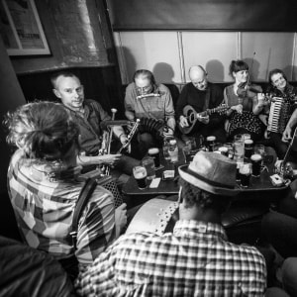
Markievicz Road & Holborn Street, Sligo
Tel: +353 (0)71 9194920
http://www.thomasconnollysligo.com/
Overnight Sligo Town – for a range of Fáilte Ireland approved accommodation options please click here

Day 5

Morning

Visit Sligo’s Signature Discovery Point, Mullaghmore Head

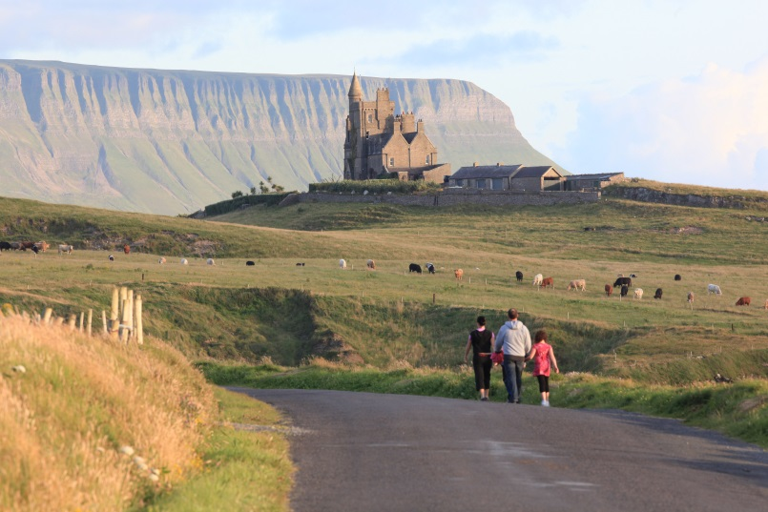

Walk round breath taking Mullaghmore Head with views of Benbulben and Donegal Bay. Don’t forget your camera!

Meet the Makers of Donegal - Donegal Craft Village
Donegal Craft Village is a showcase for Ireland’s many contemporary arts and
crafts. Stop in and meet the makers in their workshops before picking up a unique
item or two to bring home as a memento of your time on the Wild Atlantic Way.
You can also rest and recharge at the award-winning, on-site restaurant, Aroma,
which is known for its delicious homemade cakes and gourmet lunches. The beautiful
grounds include a picnic area, charming courtyard and spacious car park that
can accommodate coaches.

Lunch at Aroma Café, Donegal Craft Village
2016 Winner Best Café in Donegal at the Irish restaurant awards.
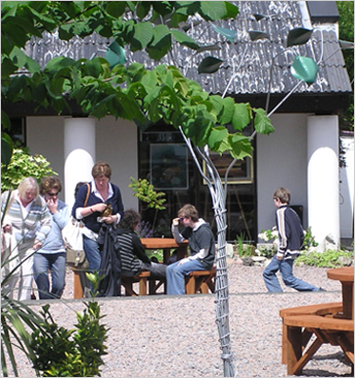
Ardara, Co Donegal
Tel: +353 (0)74 9725928
Email: lyndseymcgonigle@yahoo.co.uk
http://www.donegalcraftvillage.com/

Afternoon

Travel to Sliabh Liag and walk the Pilgrim’s Path and/or experience Sliabh Liag by boat
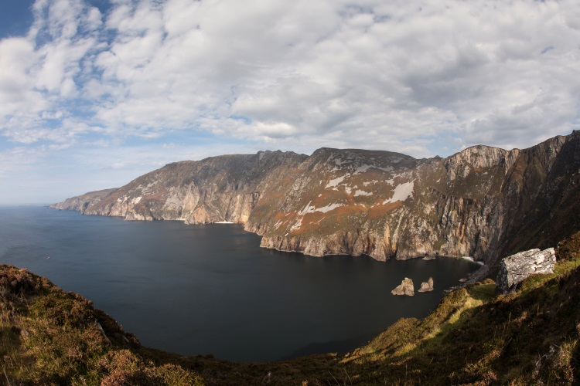

The Pilgrim Path at Sliabh Liag (Slieve League) offers a different way of experiencing these spectacular cliffs, which are among the highest in Europe. This moderate walking route is only 2.8km long, but features views of the villages of Teelin and Carrick and finishes up looking down upon the cliffs. On your excursion, you’ll also get a glimpse into the ancient history of this mystical location, passing church ruins and a holy well on the eastern summit of Sliabh Liag.

Enjoy the spectacular sight of the Slieve Liag sea cliffs on the Nuala Star, a 36ft passenger boat. If you are lucky enough, you may even be joined by wild life including dolphins, whales and seals. In May and June there are often basking sharks to be seen feeding on the plankton. There is also a wide range of bird life, which can be seen nesting and hunting. Nuala Star also offer enjoyable angling trips and don’t forget to ask Paddy about swimming in the small caves.
Sliabh Liag Cultural Centre, Teelin, Carrick, Co. Donegal
Contact: Paddy Clarke
paddy@sliabyleaguecliffs.ie
T: +353 (0) 74 9739077
www.sliabhleague.com

Evening

Dinner at The Olde Castle Bar and Restaurant
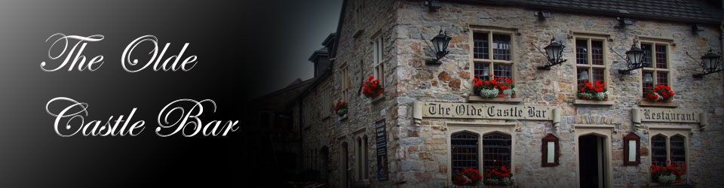

Castle Street, Donegal Town
Tel: +353 (0)74 9721262
http://www.oldecastlebar.com/

Traditional music session at The Reel Inn Bar, Donegal Town, Co. Donegal

Overnight Donegal Town – for a range of Fáilte Ireland approved accommodation options please click here

Day 6

Travel from Donegal Town to Annagry, Co. Donegal

Morning
Option 1 - Paddle the Day Away
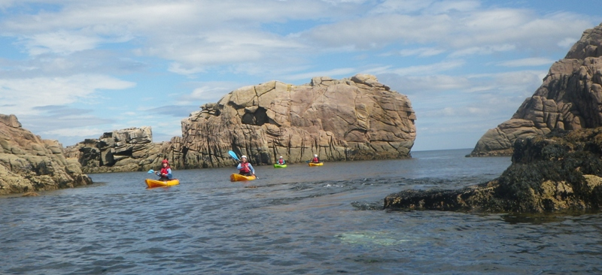
Stunning seabirds, breath-taking beaches and basking sharks? A sit-on-top kayak is the ideal way to explore the sights and sounds of west Donegal.
To experience west Donegal’s stunning Atlantic coastline from the water rather than land, join a sea kayaking tour of the region. Using a sit-on-top sea kayak, you’ll paddle your way to isolated beaches, rugged islands and eerie caves, while also getting a close-up view of fascinating rock formations and sea arches that are accessible only from the water.
You’ll also want to keep your eyes peeled – and cameras ready – for wildlife sightings, as seabirds, seals, dolphins and even basking sharks can be spotted in this idyllic area.

Rapid Kayaking
Annagry, Co Donegal
Tel: +353(0)86 1510979
Email: rapidkayaking@gmail.com
www.rapidkayaking.com

Option 2 - Gallop Donegal’s Wild Atlantic Way at Dunfanaghy Stables, Dunfanaghy, Co. Donegal
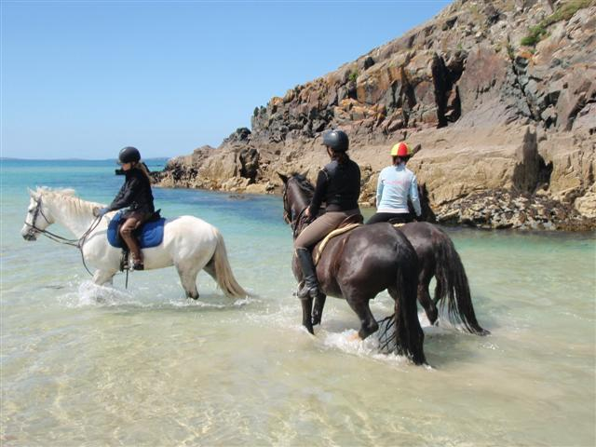
Leave your cares behind as you canter to the sound of the roaring Atlantic in the seaside resort of Dunfanaghy. Explore the region’s varied terrain on horseback, trekking into the mountains, over sandy beaches and through areas where Irish is still the primary language. Afterwards, stop into a local eatery and enjoy a relaxing cup of tea, a specially made cocktail or a few scoops of ice cream. And don’t forget to chat with the locals, who will no doubt share ideas for your next thrilling holiday experience.
Tel: +353 (0)74 9100980 or +353 (0)86 8280552
Email: dunfanaghystables@hotmail.com
www.dunfanaghystables.com

Afternoon

Sea Stack Climbing on Gola Island
For a more high octance experience adventure through Donegal with Unique Ascent, Co. Donegal.
Get the boat across to Gola Island with Unique Ascent and climb a sea stack and see the Wild Atlantic Way from a completely different angle!
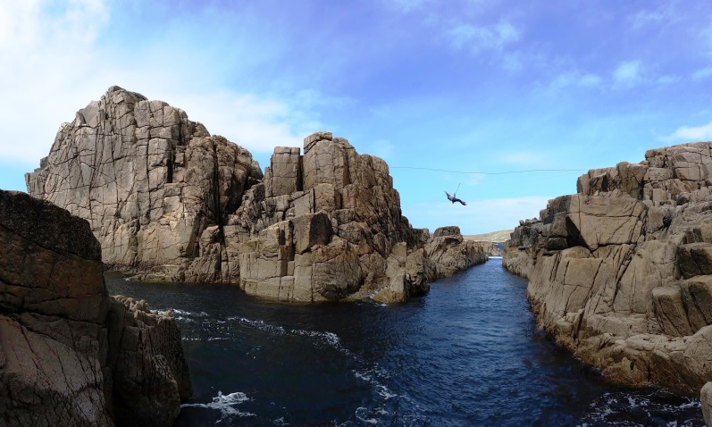

What Gola Island provides is outstanding rock climbing in a wild, remote and truly beautiful setting. The island sits far out in Co Donegal's rain shadow and it is not unusual to be climbing on the island in bright sunshine and blue skies whilst the rest of the county is under a deluge of heavy rain.
Contact: Iain Miller
Tel: +353 (0)87 7584810
Email: uniqueascent@gmail.com
www.uniqueascent.ie/

Evening

Dinner at Danny Minnie’s Restaurant and Accommodation
Danny Minnie's is a long-established, award-winning restaurant situated in West Donegal, in the heart of the Gaelic-speaking Gaeltacht. The restaurant offers high-quality local seafood and meats in a cosy, welcoming atmosphere.
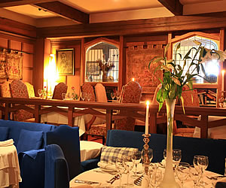
Annagry, The Rosses, Co. Donegal
Tel: +353 (0)74 9548201
Email: info@dannyminnies.ie www.dannyminnies.ie

Overnight Gweedore – for a range of Fáilte Ireland approved accommodation options please click here

